**Report**

**Fist project--quad tree**

XJCO1921 Programming Project

KUANG TING

Leeds username:sc17tk

Leeds ID number:201199532

**Task 1**

**Algorithm:**

**Testing:**

1. **a full tree at Level 2**

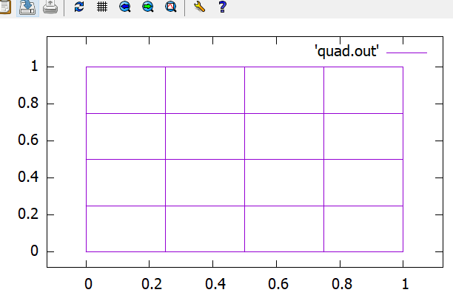

**Destroy it--- valgrind**

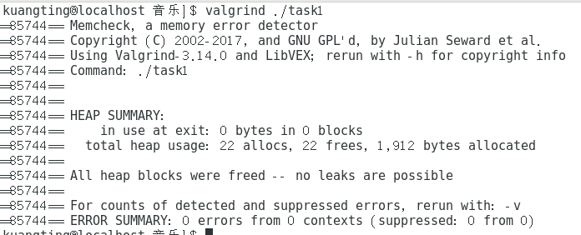

1. **a non-uniform tree**

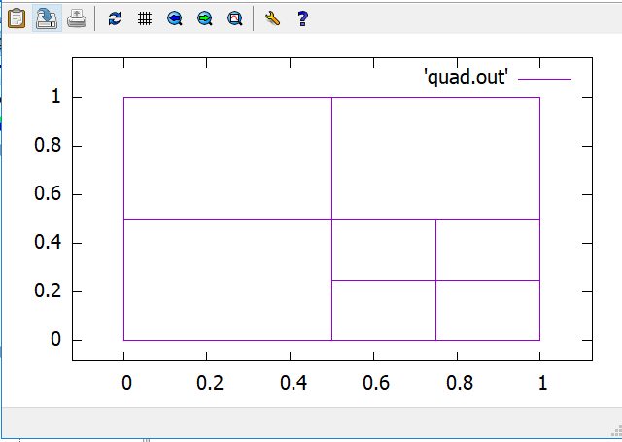

**Destroy it**

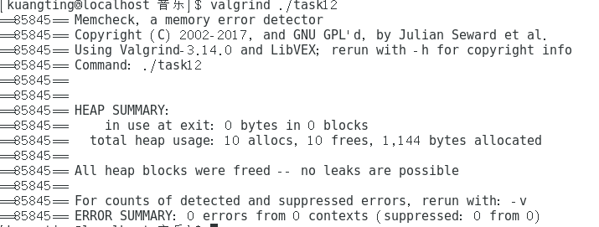

**Task 2**

**Algorithm:**

**Testing :**

**Remove child[1] in level 2 from a full tree at Level 2.**

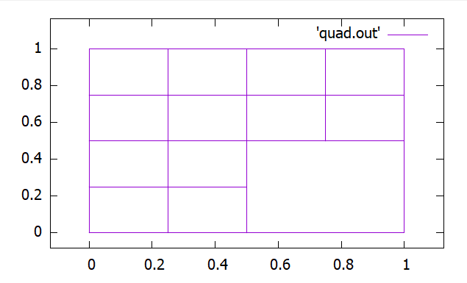

**----valgrind**

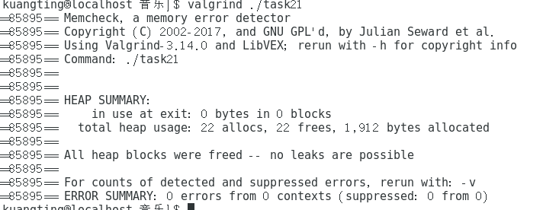

**a non-uniform tree**

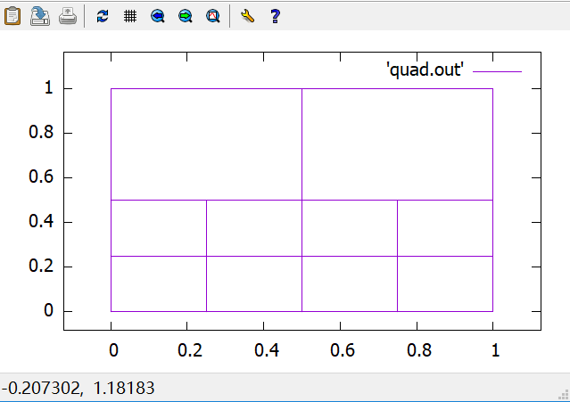

**Remove child [1] in level 2 from a non-uniform tree**

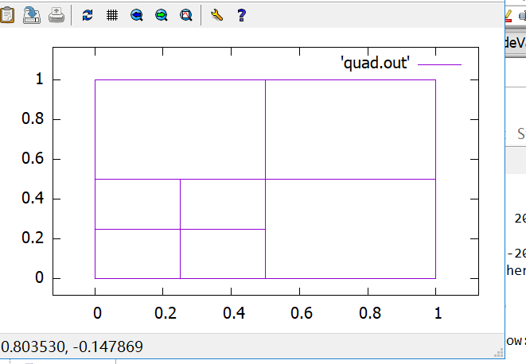

**-----valgrind**

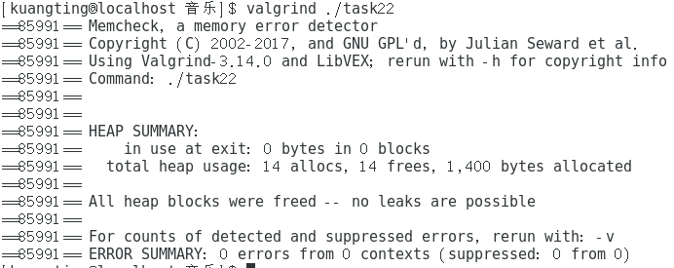

**Task 3**

**Algorithm:**

**Testing:**



